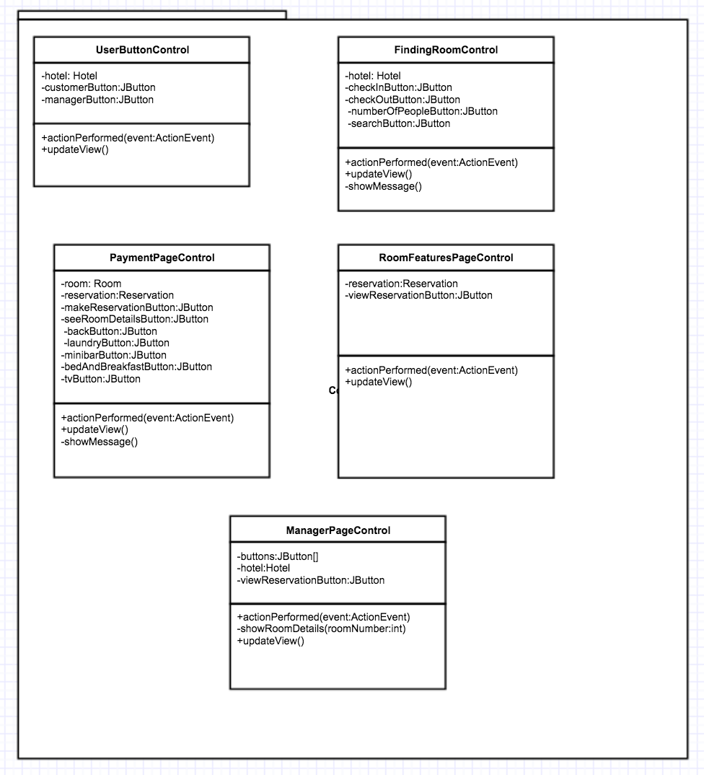

Controller subsystem consists of several classes which have controller role between model classes and view classes. The classes in the controller subsystem are “UserButtonControl”, “FindingRoomControl”, “PaymentPageControl”, “RoomFeaturesPageControl”, and “ManagerPageControl”. These all classes provide a connection between user interfaces and the reservation system objects.

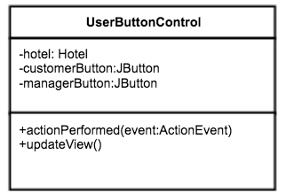

* “UserButtonControl” class manages the main page. ‘Customer’ and ‘Manager’ buttons which are in the main page. Its methods and properties are explained below.

**actionPerformed(event: ActionEvent)** uses hotel object and buttons which are ‘Customer’ and ‘Manager’ . According to the button name it updates the view by using the **updateView(**) method.

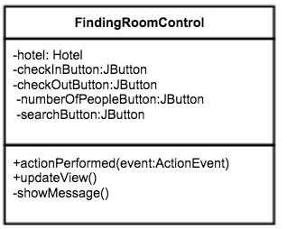

* “FindingRoomControl” class manages the make reservation step. It uses hotel object, reservation object and also checIn, checkout, numberOfRooms and search buttons. After the user enters the check in check out dates etc., he or she must click the search button. After this step, if a proper room is found new page which is payment page is opened by **updateView(**) method. However, there is no proper room **updateView()** method use **showMessage()** method to show information to user about not finding proper room.

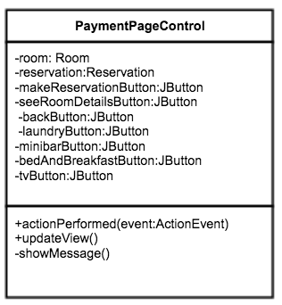

* “PaymentPageControl” class manages the payment page. If the proper room is found. Therefore, it uses reservation object, and buttons which are make reservation, see room details, back buttons. This class also have buttons for room features. These buttons are laundry, mini bar, bed & breakfast and TV. By clicking these buttons user can state the room features. For these purposes, **actionPerformed(event: ActionEvent)** , **updateView()** and **showMessage()** methods are used.

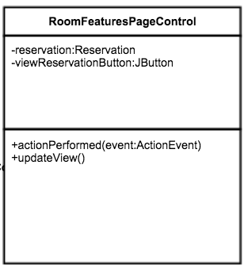

* “RoomFeaturesPageControl” class manages the room features page. It uses control objects whose type is room and reservation to see the details of room that belongs to the specific reservation. And update the view by showing the details of this room.

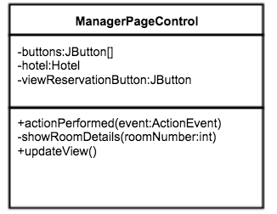

* “ManagerPageControl” class manages the manager main page. It uses a control object whose type is hotel and buttons array which holds the all rooms in the hotel. When the manager clicks any button for a room in the hotel, shows the details of all reservations which are made for this room.